Master Fastener Ship List Macro Usage Instructions

Every computer with Excel has a document called "Personal Macro Workbook.xlsb" which can store macros so that they are present in any instance of Excel opened from that point forward. This is as opposed to storing a macro in a specific workbook. The steps below are to add the macro to prepare the master fastener ship list to your Personal Macro Workbook.

1. The macro is stored in a word document in my shared folder
   1. document name = Sub CreateMasterFastenerShipList.docx
   2. directory = W:\*REDACTED*\Excel Macros
2. Open the document and copy all the text in it to your clipboard.
3. On the AX computer, Close all running Excel processes and windows first
4. Still on the AX computer, open a blank Excel workbook
5. Go to add-ins, and check the "Developer" tab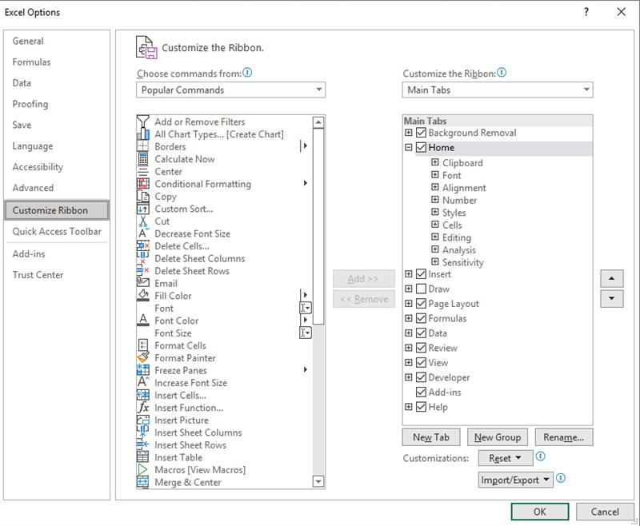
6. Hit "OK" to exit the Excel options window
7. Click the Developer Tab
8. Click "Record Macro"
9. Enter "CreateMasterFastenerShipList" in the "Macro Name:" field and select "Personal Macro Workbook" from the "Store macro in:" drop down.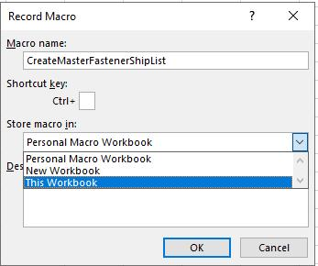
10. In the bottom left-hand corner, hit the stop sign to stop recording the macro.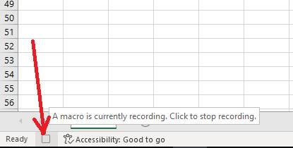
11. Click the "View" tab
12. Click "Unhide"
13. Select "OK" with "PERSONAL" highlighted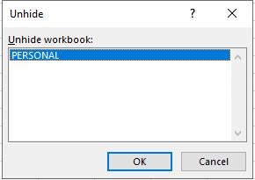
14. Click the "Developer" tab
15. Click "Macros"
16. Click "Edit" with "CreateMasterFastenerShipList" selected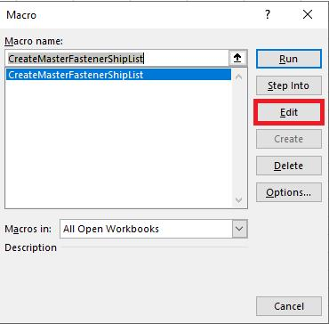
17. The window which opens is the "Microsoft Visual Basic for Applications - PERSONAL.XLSB" window. Module 1 should be active
18. Delete all text present, then paste the macro text copied from the work document.
19. Close the "Microsoft Visual Basic for Applications - PERSONAL.XLSB"
20. Click the "View" tab
21. Click "Hide"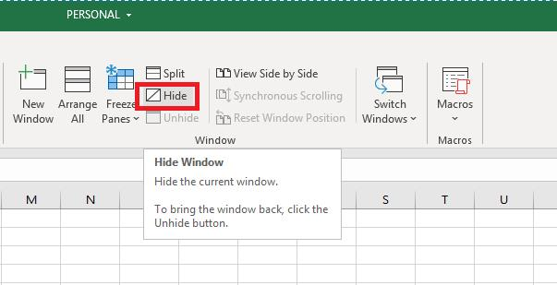
22. Close Excel
23. Click "Don't Save" when asked if you wanted to save changes to "Book1"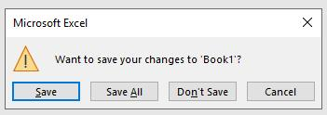
24. Click "Save" when asked if you want to save changes to the Personal Macro Workbook.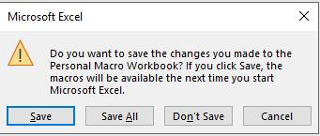
25. Make sure all ship lists are accounted for
26. Navigate to the directory where the ship lists are
27. Make sure that Sheet #1 is the sheet with only fasteners for all documents. Sheet name DOES NOT MATTER, so long as the first sheet in the document has only fasteners.
28. Right click the address bar and select "Copy address as text"
29. Open a blank Excel document
30. Click the "Developer" tab
31. Click "Macros"
32. With "PERSONAL.XLSB!CreateMasterFastenerShipList" selected, click "Run"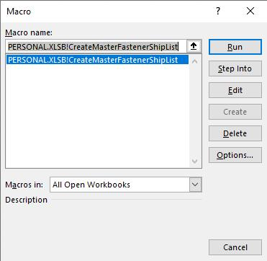
33. Paste the copied file path into the pop-up prompt
34. Click "OK"
35. INTERLUDE: the macro:
    1. opens all Excel documents and collects 200 rows of data
    2. pastes all this data into one blank sheet on a new Excel book
    3. makes a pivot table of the data on the new Excel book on a second sheet. The pivot table determines all the unique entries of text and how many times they appear
    4. opens the ExportBOMAx2012 spreadsheet
    5. imports all descriptions
    6. copies all descriptions back to the new ship list.
36. Note: when importing all descriptions, any typos in part numbers will pop up as prompt boxes. Get with the person who made each ship list with an issue as necessary to fix typos.
37. The result is an ExportBOMAX2012 spreadsheet that is ready for export and a ship list that is ready to have the customer, city, state, project, etc. filled in.
38. Note: Further instructions redacted. Some photos redacted throughout document.